Name: Zhu Jin Shun

ID:22101071d

2421 A3 DL_Programming Experiment

Report

**Requirement 1:.The truth table in subtask two and the functions relating the output 𝑆𝑗 and the input E0 E1 E2.**

Truth Table Subtask 2

|  |  |  |  |  |  |  |  |  |  |
| --- | --- | --- | --- | --- | --- | --- | --- | --- | --- |
| Input | | | Output | | | | | | |
| E0 | E1 | E2 | S1 | S2 | S3 | S4 | S5 | S6 | S7 |
| 0 | 0 | 0 | 0 | 1 | 1 | 1 | 1 | 1 | 1 |
| 1 | 0 | 0 | 0 | 0 | 0 | 1 | 0 | 0 | 1 |
| 0 | 1 | 0 | 1 | 0 | 1 | 1 | 1 | 1 | 0 |
| 1 | 1 | 0 | 1 | 0 | 1 | 1 | 0 | 1 | 1 |
| 0 | 0 | 1 | 1 | 1 | 0 | 1 | 0 | 0 | 1 |
| 1 | 0 | 1 | 1 | 1 | 1 | 0 | 0 | 1 | 1 |
| 0 | 1 | 1 | 1 | 1 | 1 | 0 | 1 | 1 | 1 |
| 1 | 1 | 1 | 0 | 0 | 1 | 1 | 0 | 0 | 1 |

Function relating the output 𝑆𝑗 and the input 𝐸0𝐸1𝐸2.

S1=f(E0E1E2)= E0'E1E2' + E0E1E2' + E0'E1'E2 + E0E1'E2 + E0'E1E2

S2=f(E0E1E2)= E0'E1'E2' + E0'E1'E2 + E0'E1E2 + E0E1'E2

S3=f(E0E1E2)= E0'E1'E2' + E0'E1E2’ + E0E1E2’ + E0E1'E2+ E0’E1E2+ +E0E1E2

= E0E2 + E1 + E0'E2’

S4=f(E0E1E2)= E0'E1'E2' + E0E1'E2' + E0'E1E2' + E0E1E2' + E0'E1'E2 + E0E1E2

S5=f(E0E1E2)= E0'E1'E2' + E0'E1E2' + E0'E1E2

S6=f(E0E1E2)= E0'E1'E2' + E0'E1E2' + E0E1E2' + E0E1'E2 + E0'E1E2

S7=f(E0E1E2)= E0'E1'E2' + E0E1‘E2‘ + E0E1E2’ + E0‘E1'E2 + E0E1’E2+ E0‘E1E2+ E0E1E2

= E0+E1’+ E2

**Requirement 2: Screen shot of the three circuits in three subtasks.**

Subtask 1:

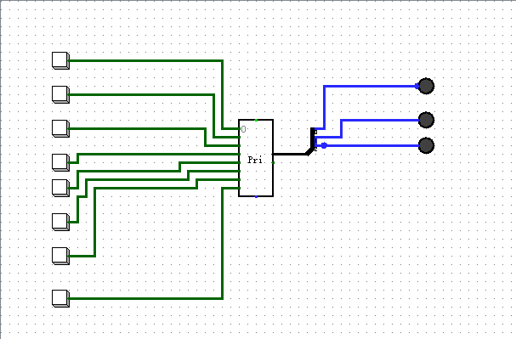

Subtask 2:

Subtask 3:

**Requirement 3: Three pictures. In each picture, you should show that when button 𝑖 is pressed, the digit 𝑖 is shown in the 7-Segment display (Select three cases as you wish).**

When 0 is pressed, digit 0 is shown in 7-segment display:

When 3 is pressed, digit 3 is shown in 7-segment display:

When 6 is pressed, digit 6 is shown in 7-segment display:

